Ex. No:6
Date:
CRM MANAGEMENT USING SALESFORCE CLOUD PLATFORM
AIM:
To create a Customer Relationship Management (CRM) system using the Salesforce.com portal.
PROCEDURE:
Step 1: Open Salesforce Website
- Open a web browser (Google Chrome, Mozilla Firefox, Edge, etc.).
- In the search bar, type "Salesforce login" or go to https://www.salesforce.com.

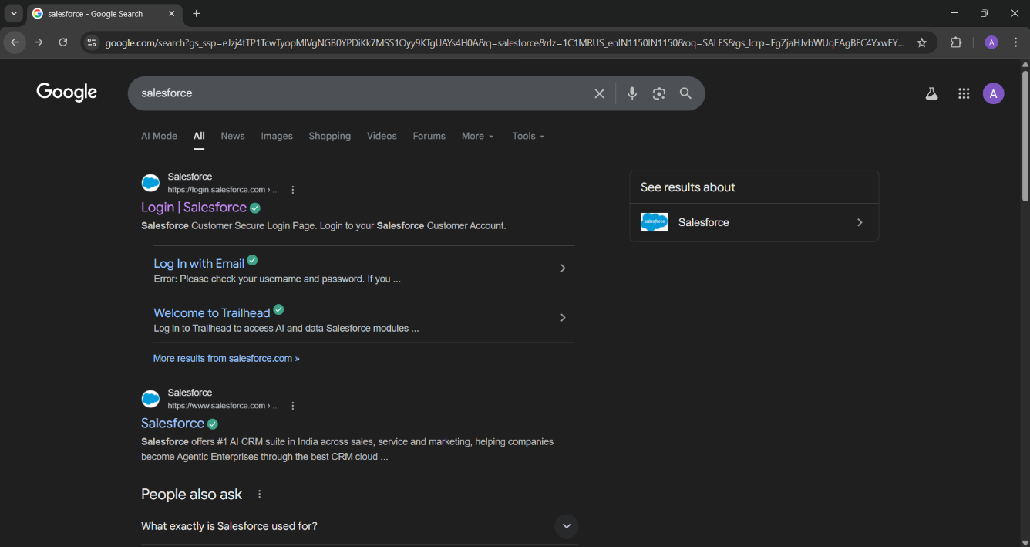

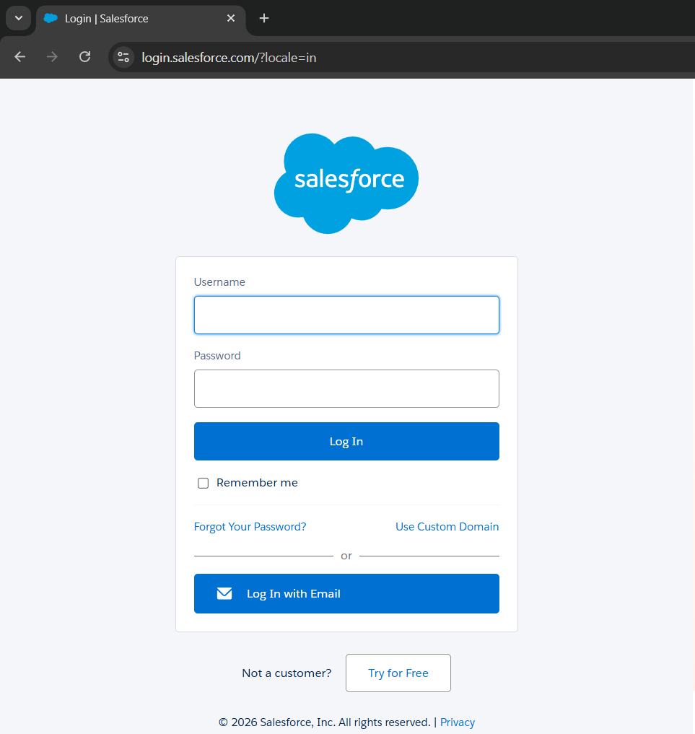

Step 2: Sign Up for Salesforce
- Click on the "Try for Free" button on the homepage.
- Fill in the required details such as First Name, Last Name, Email, Job Title, Company Name, Employees, and Phone Number.
- Click “Start Free Trial” (You may receive an email verification link to activate your account).
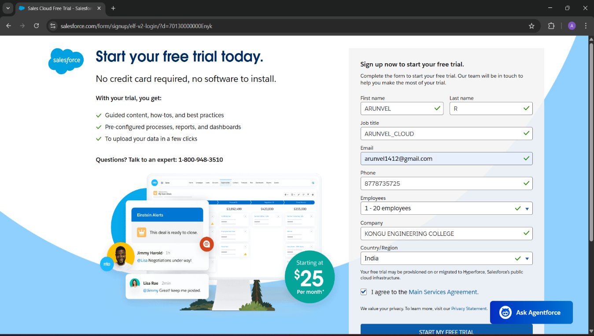

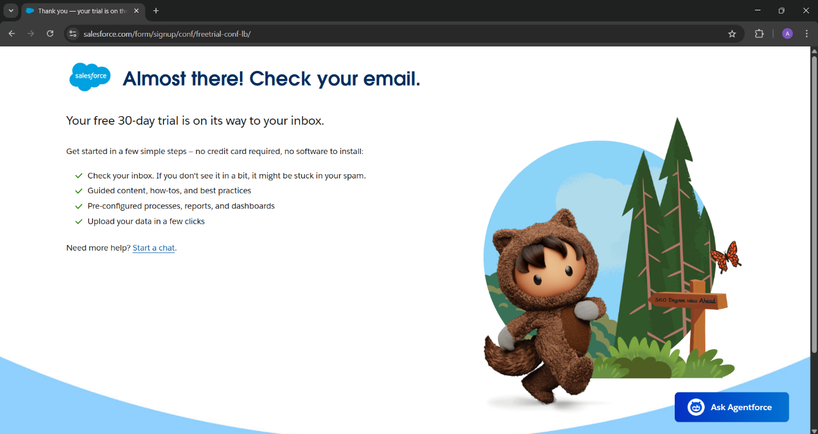

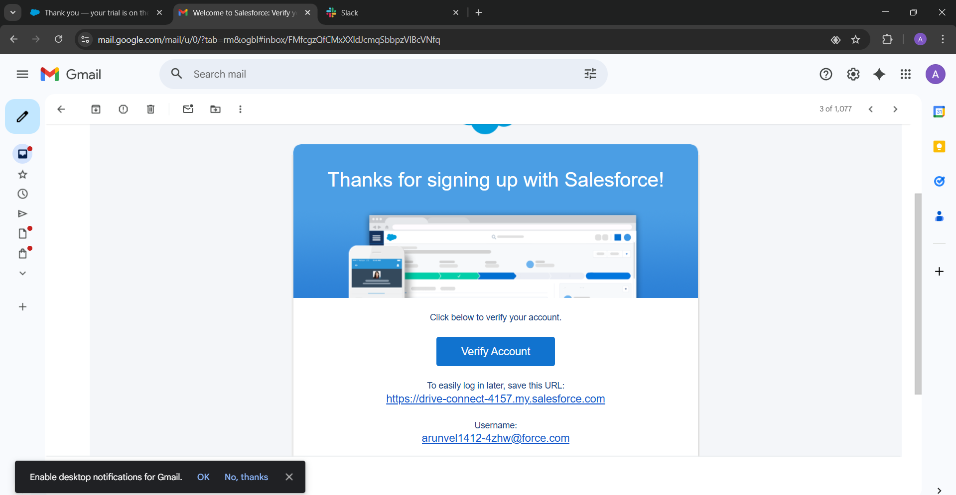

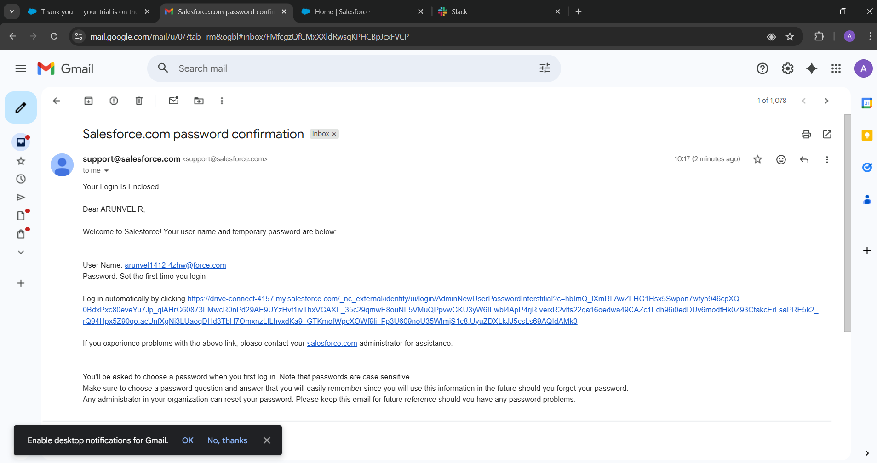

Step 3: Login to Salesforce
- After completing the sign-up process, log in to your Salesforce account using your registered email and password.
- The Salesforce Dashboard will appear, showing various modules like Leads, Accounts, Contacts, Opportunities, etc.

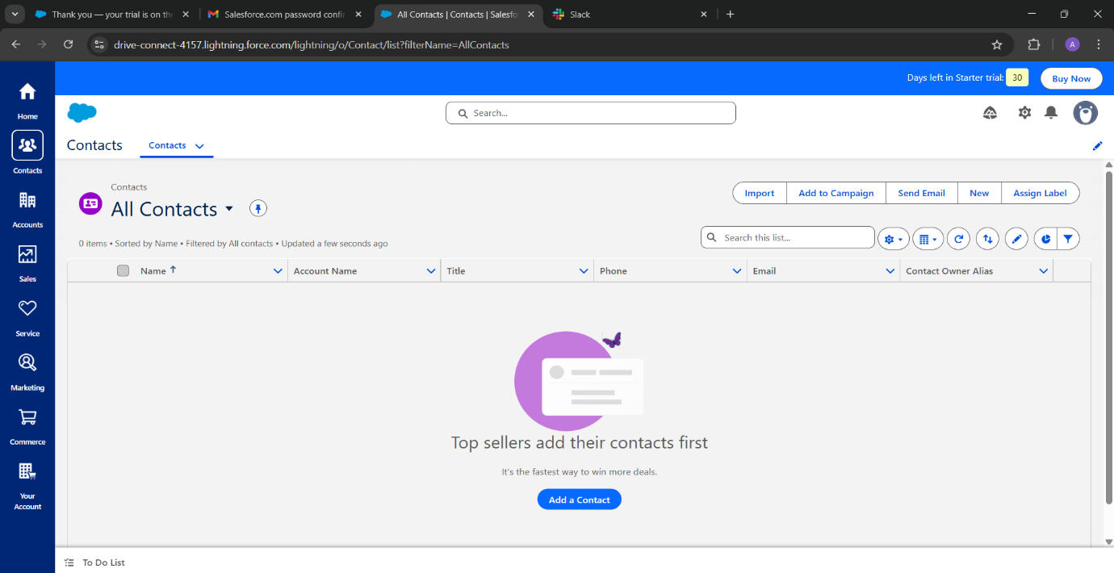
Step 4: Create a New Contact
- On the left-side panel, click on “Contacts”.
- Click on the “New” button to create a new contact.
- A pop-up dialog box appears where you need to enter the following contact details: o First Name
  - Last Name
  - Email
  - Phone Number
  - Company Name
- Click Save to store the contact information.

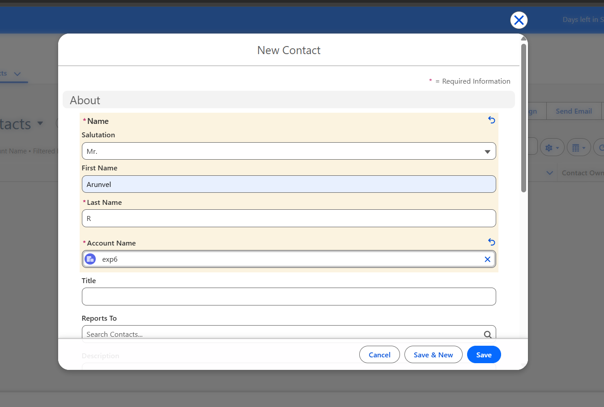

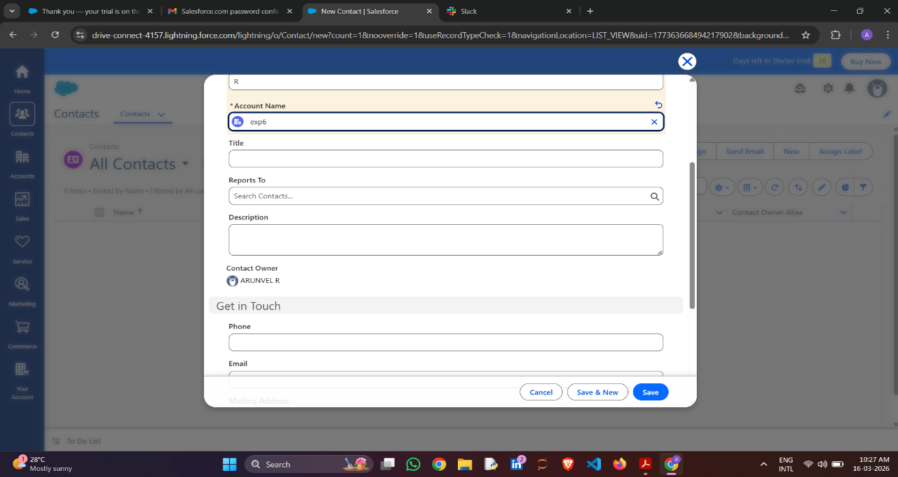

Step 5: Create a New Account
- Go to the Accounts tab.
- Click on “New” to add an account.
- Fill in the required details like: o Account Name
o Industry

o Website URL
o Phone Number
o Billing Address

- Click Save to create the account.



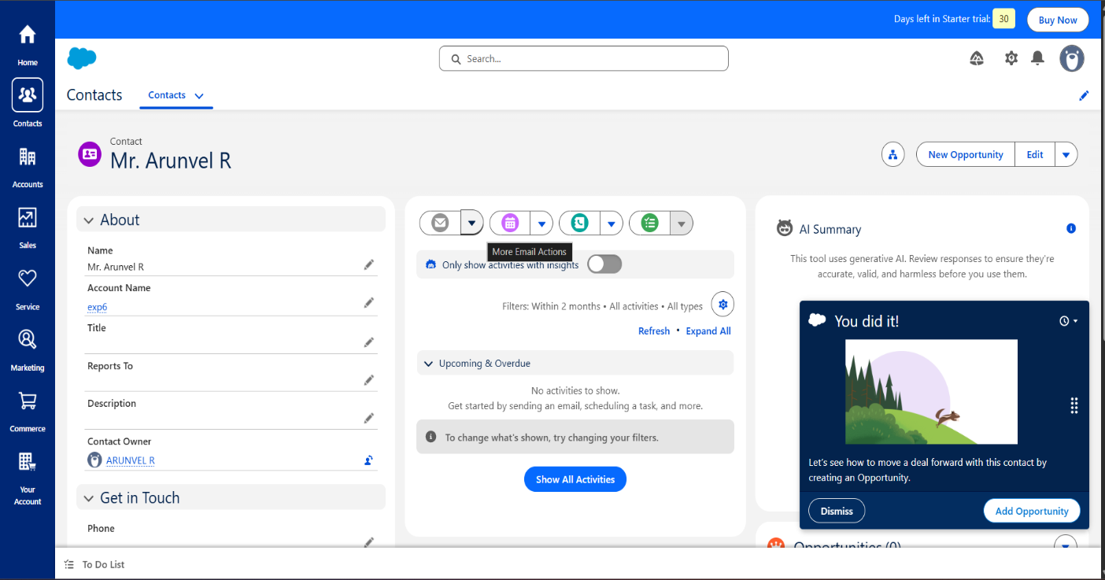

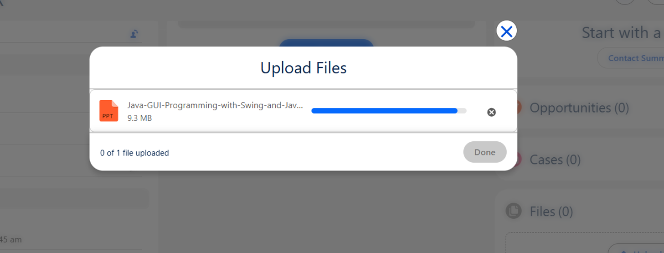

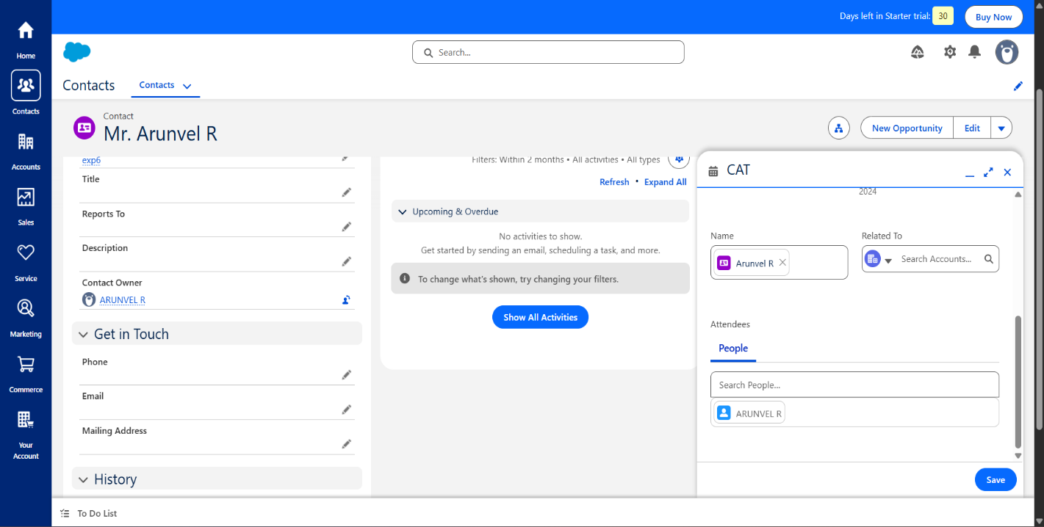
Step 6: Schedule an Event in the Calendar
- Click on the Calendar feature from the menu.
- Click on the “New Event” button.
- Enter the event details such as: o Event Name
o Date & Time
o Participants (Contacts or Accounts)
o Location
- Click Save to schedule the event.

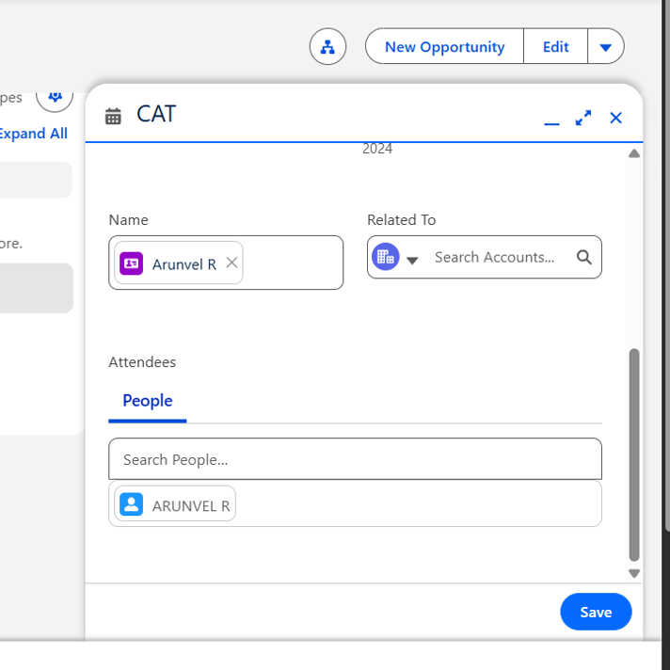
Step 7: Create a New Lead and Assign a Task
● Click on the Leads tab.
● Click “New” to create a lead.
● Fill in the required details, such as: o Lead Name
o Company
o Lead Source (Referral, Advertisement, Web, etc.)

● Click Save to add the lead.
● Now, assign a task by clicking on “Tasks”.
● Click New Task, fill in the task details, and assign it to a sales representative.
● Click Save.

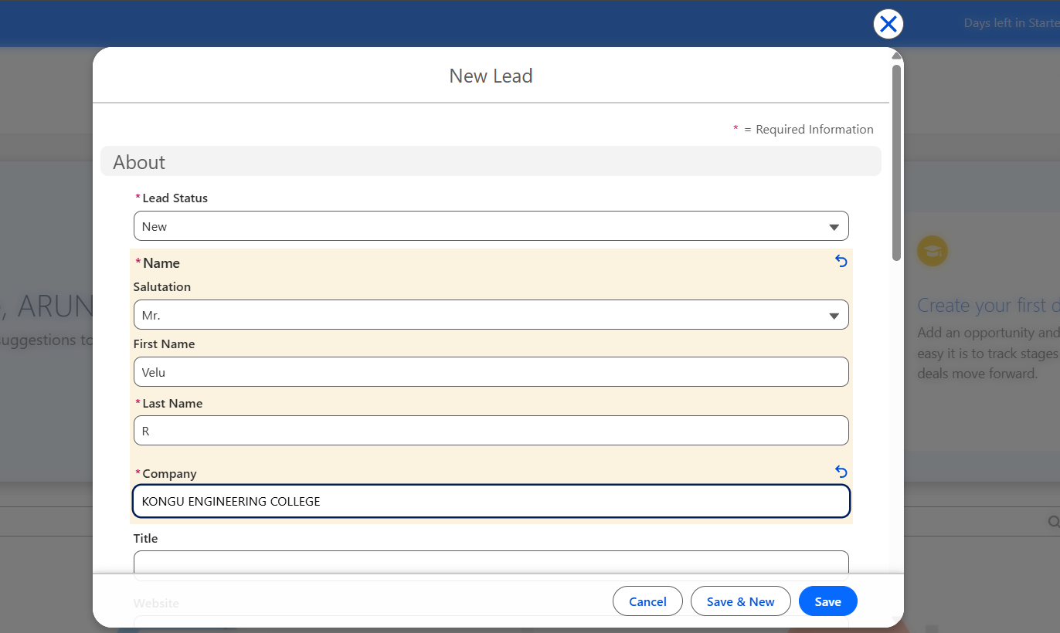

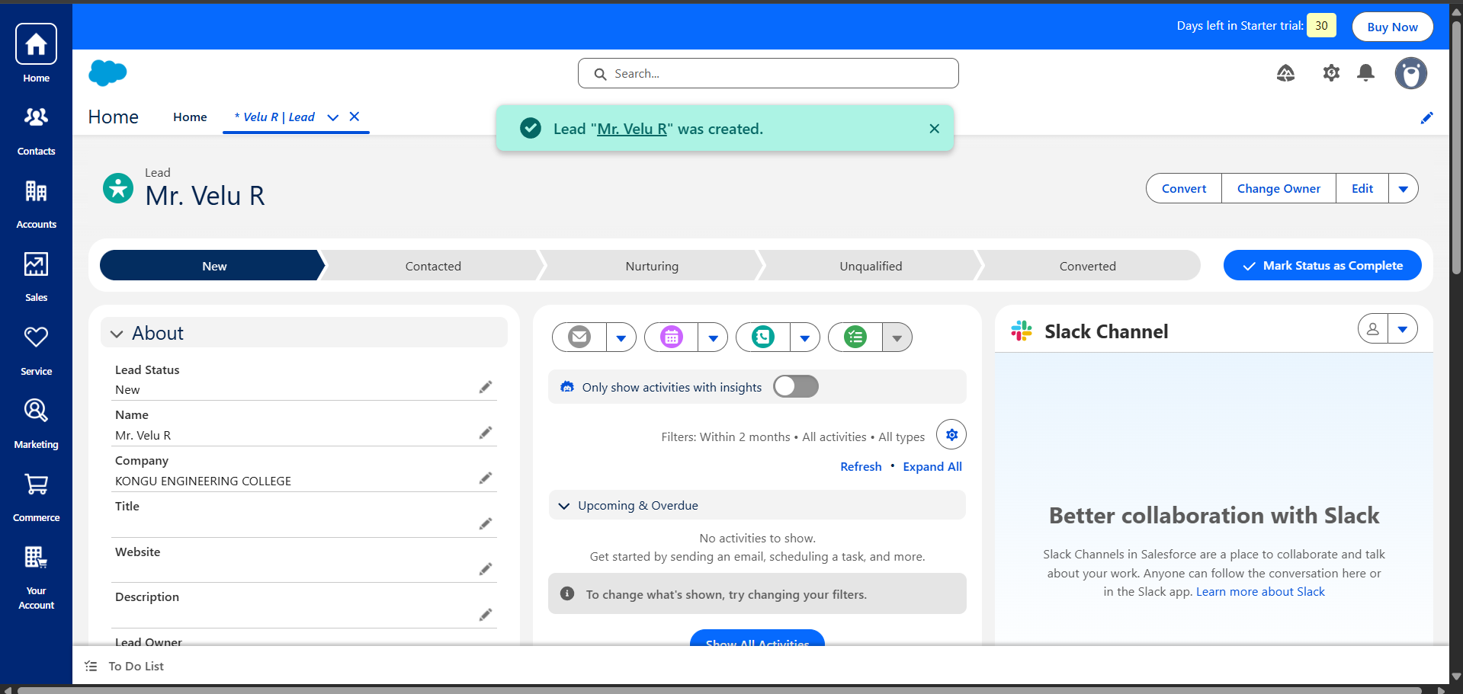

COE
Record(20)
Viva(10)
Total(60)

RESULT:
A CRM system has been successfully created using Salesforce Cloud Platform.
The system allows users to manage contacts, accounts, events, and leads effectively.

